Periodic Table History

Johnann Wolfgang Döberiner: classified elements into triads (groups of three) with similar properties.
John Newlands: arranged the elements in order of increasing atomic mass. Proposed the law of octaves.
law of octaves: when the elements are arranged by increasing atomic mass, every 8th element has similar properties. This worked for the first 20 elements.
Julius Lothar Meyer: published the first periodic table (1864), with 28 elements arranged in order of increasing atomic mass and grouped according to valence numbers.
Dmitri Mendeleev: considered the author of the modern periodic table. Published in 1869, with elements arranged by increasing atomic mass, and grouped in columns by chem. & phys. properties.
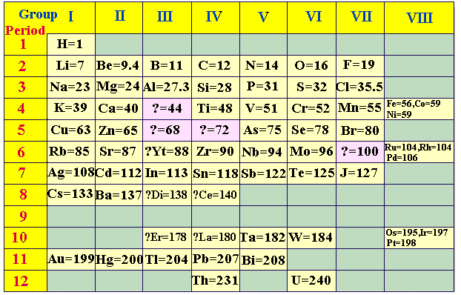
Mendeleev correctly predicted the existence and chemical and physical properties of undiscovered elements gallium (“eka-aluminum”) and germanium (“eka-silicon”).
Mendeleev’s groups were chosen first based on the elements having chemical and physical properties, and second based on arranging the elements by increasing atomic mass. Tellurium (Te) was later found to have an average atomic mass of 128 (heavier than iodine, which was “J” on Mendeleev’s table), but Mendeleev kept the elements where they were, because tellurium is more like the other elements in group 6, and iodine is more like the other elements in group 7.
periodic law: when the elements are arranged in order of increasing atomic number, their properties repeat in regular intervals (periods).
Henry Moseley: (1913) rearranged the elements by increasing nuclear charge (atomic number) instead of atomic mass. This fixed the exceptions in Mendeleev’s table.

