Electron Energy Transitions
quantum: a discrete quantity of energy that cannot be divided.

ground state: the lowest available energy level for an electron.

excited state: a higher energy level than the ground state.

emission spectrum: the wavelengths (colors) of light emitted by an element when its electrons are “excited” (raised to a higher energy state) and then allowed to return to the ground state.

Hydrogen:


Iron:
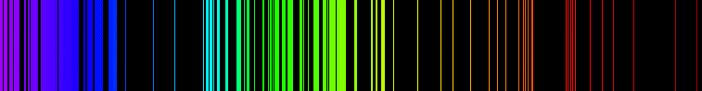
photon: a single “piece” (particle/wave) of light.
luminescence: light that is not generated by high temperatures alone. (In fact, it usually occurs at low temperatures. Causes include electrical energy and chemical reactions .
fluorescence: a type of luminescence that occurs when electrons of an element are excited and return immediately to the ground state, giving off a photon. The wavelength of the photon given off is usually different from the wavelength of the photon used to raise the electrons to the excited state.
phosphorescence: “glow-in-the-dark” luminescence—a type of luminescence that occurs when electrons are excited, but cannot return directly to the ground state. The indirect path is slower, which cause the material to “glow” for a longer period of time (in some cases, hours).
triboluminescence: a form of luminescence in which light is generated by breaking asymmetrical bonds in a crystal. In the case of wintergreen Life Savers, when the sugar crystals are crushed, the positive and negative charges get separated. The voltage between them causes a spark. Normally, these sparks are in the ultraviolet part of the spectrum and cannot be seen; however, wintergreen oil (methyl salicylate) is fluorescent. It absorbs the photons of ultraviolet light and emits photons of blue light, which we can see.

