Modern Atomic Theory
Neils Bohr: realized that atomic spectral emissions are quantized, which means electron energy levels must also be quantized.

Rutherford-Bohr model: a model of the atom in which the distance from the nucleus to an electron equals the electron’s (quantum) energy level. Sometimes called the “planetary model” because it looks like a solar system, with the nucleus in place of the sun and electrons in place of the planets.

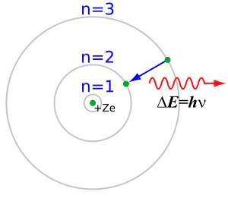
What actually happens is not that simple. In reality, if an electron is in the first quantum energy level (n = 1 in the preceding diagram), the Bohr model may predict its average distance from the nucleus, but the electron is free to move around. If we took several pictures of a hydrogen atom with its one electron over time, it might look like this:

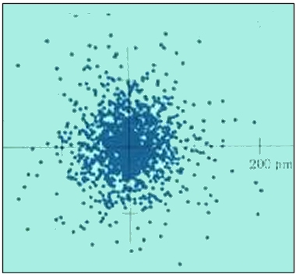

It would be more accurate to say that the electron has a high probability of being found anywhere inside a spherical region around the nucleus.

Energy Level Hierarchy

If we were to plot the regions where there is a high probability of finding an electron, we would have to solve and plot the wave equation, which would require extremely advanced mathematics. Each of the different energy levels in the Rutherford-Bohr model has regions with different shapes where electrons may be found.

It’s easiest to understand how this works if we look the hierarchy first. Each level has one or more kinds of sublevels. Each sublevel has one or more orbitals, and each orbital can have up to two electrons. You can think of the hierarchy as an outline:

- energy level (1, 2, 3, ...)
  - sub-level (s, p, d, f, ...)
    - orbitals
        - individual electrons

Energy Levels
The main or principal level is a measure of total distance from the nucleus. The levels are numbered 1-7. The Period (row number) that an element on the periodic table is in gives the highest energy level of any of that atom’s electrons.

For example, helium is in period (row) #1. That means its highest energy level is 1, which means both of its electrons have to be in level 1.

Sulfur is in period (row) #3, which means it has electrons in levels 1, 2, and 3.

Sub-Levels & Orbitals
The sub-level defines the number and shapes of the orbitals (regions) where the electrons exist. Each orbital can hold up to 2 electrons.

There are four kinds of sub-levels: s, p, d, and f. The shapes of their orbitals are:

sub-level | shape(s) of orbitals | # of orbitals | # of electrons
s | 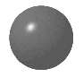 | 1 | 2
p | 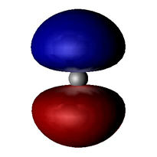 | 3 | 6
d | 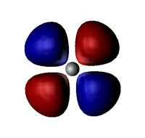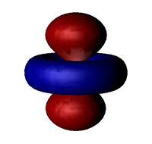 | 5 | 10
f | 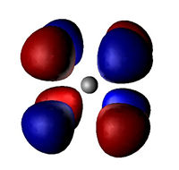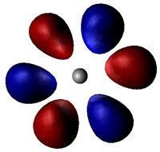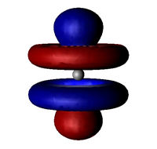 | 7 | 14

Notice that each sub-level has an odd number of orbitals.
Each level has the same number of kinds of sublevels as the number of the level:

level | # sublevels | kinds of sublevels
1 | 1 | s
2 | 2 | s, p
3 | 3 | s, p, d
4 | 4 | s, p, d, f
5 | 5 | s, p, d, f, (g)
6 | 6 | s, p, d, f, (g), (h)
... | ... | ...

The sub-levels correspond to regions of the periodic table:

Notice, for example, that the s section of the periodic table is two columns wide. This is because each s sub-level holds two electrons.

sub-level | # electrons | # columns
s | 2 | 2
p | 6 | 6
d | 10 | 10
f | 14 | 14

