Polar Bonds
polar: anything with two opposite sides that are opposite with respect to something. For example, a battery is polar because it has a positive and negative end.
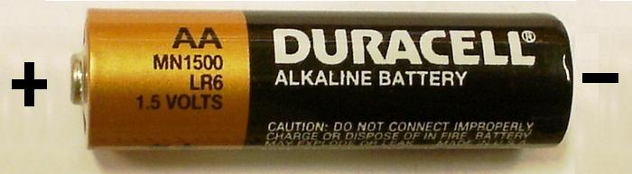
polar bond: a covalent bond that has opposite partial charges on each side (one side partially positive and one side partially negative), because of unequal sharing of electrons.
For example: The bond between H and Cl in the H-Cl molecule is a polar bond.
The bond is polar because hydrogen and chlorine share a pair of electrons, but the sharing is not equal. Chlorine has an electronegativity of 3.16, but hydrogen has an electronegativity of only 2.2. This means the electrons spend more time with chlorine than with hydrogen.
One way to show a polar bond is by using a wedge-shaped bond, which is wider on the side where the electrons spend the most time. The HCl molecule would look like this:
The wedge is narrower on the H side and wider on the Cl side because the chlorine atom has the electrons more of the time.
It is also common to label atoms in the structure with partial charges. The lower-case Greek letter “delta” (δ) is used to mean “partial”. A partially positive charge would be shown as δ+ and a partially negative charge would be shown as δ−, as in the following example:
In the above example, hydrogen has a partial positive charge, and chlorine has a partial negative charge.

Bond Type vs. Bond Character
bond type: whether a bond is actually ionic or covalent. This just depends on what types of elements the bond is joining.
- ionic bond: between a metal & nonmetal
- covalent bond: between two nonmetals
bond character: what a bond acts like, based on the difference between the electronegativities of the two elements. Note that a covalent bond may have ionic character, and an ionic bond may have covalent character.
Electronegativity Difference | Bond Character
0.35 or less | nonpolar
between 0.35 and 1.7 | polar
1.7 or more | ionic

Different sources give different numbers, usually 0.3−0.4. In almost all cases, the electronegativity difference between carbon and hydrogen is the largest difference that is still considered nonpolar.

