Polar Molecules
polar bond: a covalent bond that has opposite partial charges on each side (one side partially positive and one side partially negative), because of unequal sharing of electrons.
polar molecule: a molecule that can be turned so that it has opposite partial charges on opposite sides.
In order to be polar, a molecule must have both:
- one or more polar bonds
- an “axis of assymetry,” meaning a way to view the molecule so that there is more partial positive charge on one side (relative to the central atom), and more partial negative charge on the opposite side.
For example, the CH₃Cl molecule is polar, because the C-Cl bond is polar (Δχ = 0.61), and because you can view the central atom (carbon) so that the negative charge (towards chlorine) is on one side:
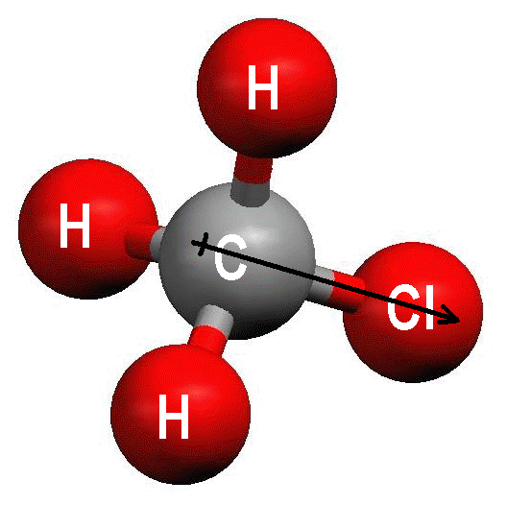
Notice the polarity arrow running from C to Cl in the molecule. The arrow shows the direction of polarization (pointing towards the more electronegative atom), and the “+” at the tail of the arrow indicates the end that has the partial positive (δ+) charge. Polarity arrows are often used with Lewis structures:
Because lone pairs of electrons change the symmetry of the molecule, trigonal pyramidal and bent molecules that contain polar bonds will usually be polar molecules. For example, NH₃ is polarized towards the nitrogen atom:
and water is polarized towards the oxygen atom:
If a molecule has multiple polar bonds that are pulling equally in opposite directions, then the forces cancel out and the molecule is not polar. An example of a nonpolar molecule that does have polar bonds is CCl₄.
Each of the C-Cl bonds is polar, but the forces all cancel out, so there is no net force in any direction.

