VSEPR Theory
Valence Shell Electron Pair Repulsion (VSEPR) theory: a theory that the shape of a molecule is determined by the repulsion between electrons in the bonds and unshared pairs of the atoms.
Electrons are all negatively charged, so they repel each other. Valence electrons exist in two places:
- unshared electrons (in pairs), attached to only one atom
- as part of a covalent bond (shared pair of electrons) between two atoms
The VSEPR shape of the molecule is the shape that occurs when all of these “clouds” of electrons are as far apart as possible.
The Lewis structure of a molecule represents the structure in 2 dimensions. The VSEPR shape is the 3-dimensional equivalent.
For example, in CH₄, the electron clouds around carbon are the four bonds to the hydrogen atoms. These electrons repel, which means they get as far apart as possible. In the Lewis structure, we draw the bonds at 90° angles, which is as far apart as possible in a 2-dimensional drawing:
However, the molecule is really 3-dimensional. This means the bonds are actually equally spaced around a sphere. This would result in a 3-dimensional molecule, with the hydrogens at 109.5° angles around the carbon atom:
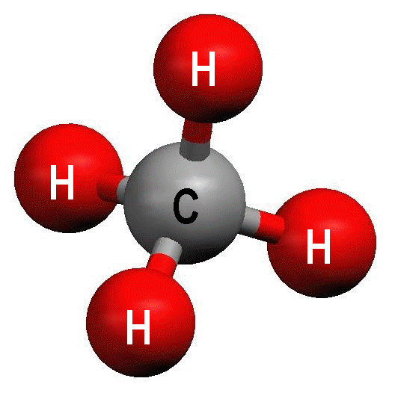
If we described this molecule as a geometric shape, it would be a tetrahedron, with the carbon atom in the center and hydrogen atoms at the vertices:
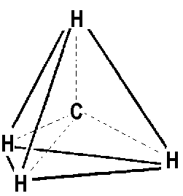
This means that, according to VSEPR theory, CH₄ is a “tetrahedral” molecule.
Now, consider the NH₃ molecule. The Lewis structure looks like this:
The “lone pair” of electrons above the N atom and the three bonds all repel each other.
This gives four electron clouds, just like CH₄:
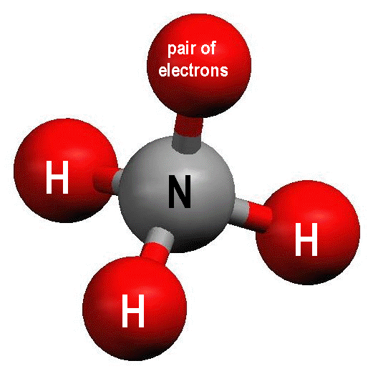
However, when we look at the shape of the molecule, we can’t see the lone pair of electrons. What we would actually see is the following:
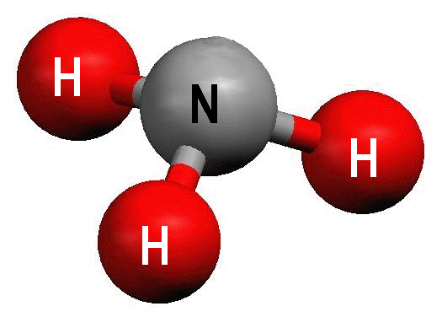
The shape of the molecule is a triangular pyramid, so the VSEPR shape of NH₃ is “trigonal pyramidal”:
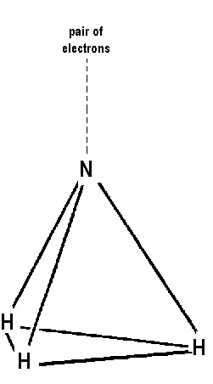
H₂O has two bonds to hydrogen atoms, and two lone pairs of electrons:
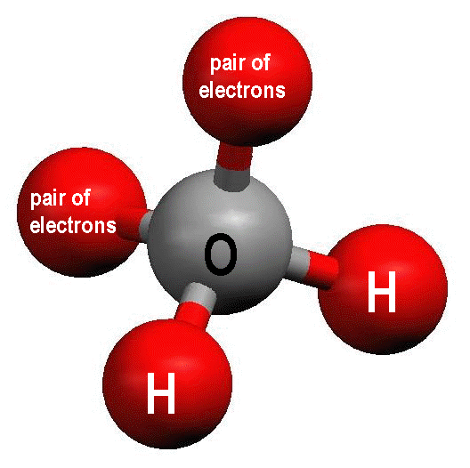
The VSEPR shape of the H₂O molecule is therefore “bent”:
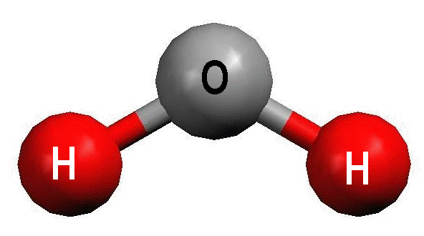

Now, suppose we have a molecule with a double bond, such as CH₂O. The Lewis structure is:
The electrons around the carbon atom are in three clouds, two smaller clouds for the C-H single bonds, and one larger cloud for the C=O double bond.
If these bonds got as far apart as possible in 3-dimensional space, they would be the points of a triangle, all in the same plane. This means that CH₂O is a “trigonal planar” molecule:
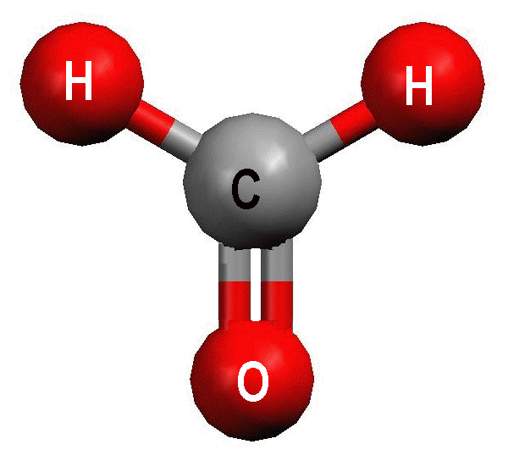
Finally, the CO₂ molecule has the following Lewis structure:
It has two large electron clouds for the C=O double bonds. The farthest these clounds can be from each other is 180° apart. This means the molecule forms a straight line, and its VSEPR shape is “linear”:
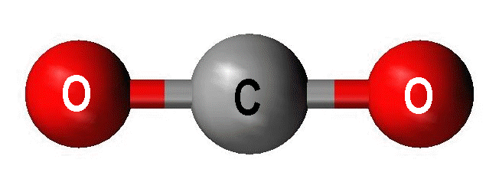
Table of VSEPR Shapes
Total # Electron Clouds | Bond Atoms | Lone Pairs | Hybridization | Bond Angle | Picture | VSEPR Shape
4 | 4 | 0 | sp ³ | 109.5° | 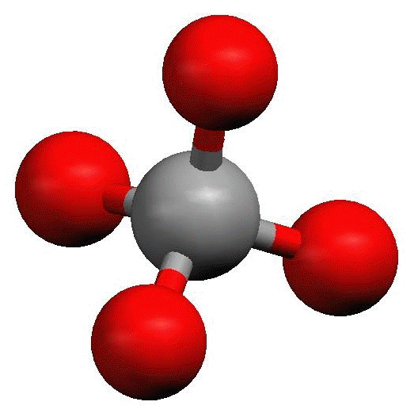 | tetrahedral
4 | 3 | 1 | sp ³ | 107.5° | 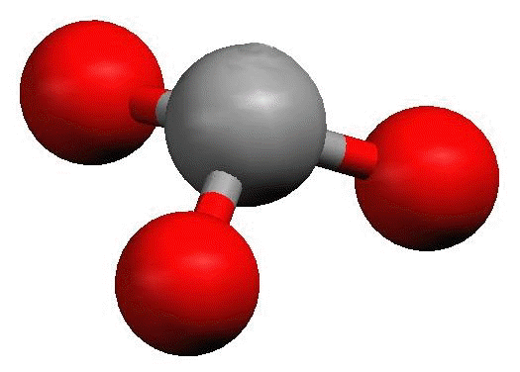 | trigonal pyramidal
4 | 2 | 2 | sp ³ | 104.5° | 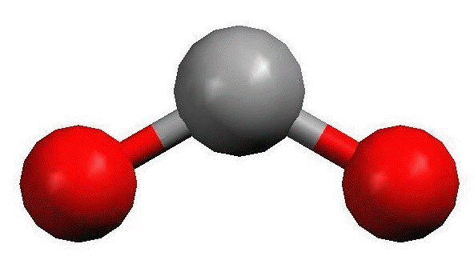 | bent
3 | 3 | 0 | sp ² | 120° | 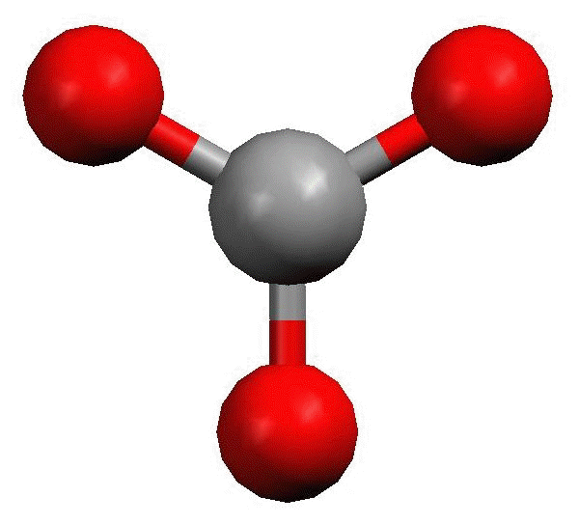 | trigonal planar
3 | 2 | 1 | sp ² | 118° |  | bent
2 | 2 | 0 | sp | 180° | 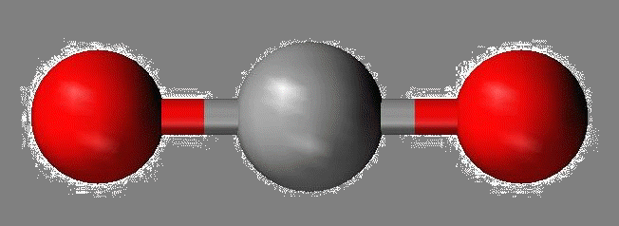 | linear

