Hybridization
orbital: the name for one of the spaces around an atom where electrons are.
When atoms form covalent bonds, the electrons move to the space between the two atoms. The space where the bonding electrons are is still called an orbital, even though its shape is now different from the shapes of the orbitals in the s, p, d, or f sub-levels of a single atom.
Recall that molecules with four electron clouds (tetrahedral, trigonal pyramidal, or bent with single bonds, like H₂O), are based on a tetrahedral VSEPR shape:
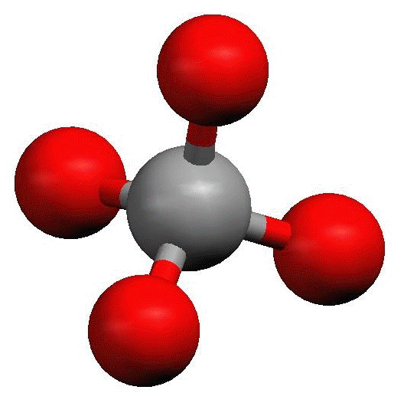
The shape of the orbitals is the shape determined by the four electron clouds. It looks like the following:
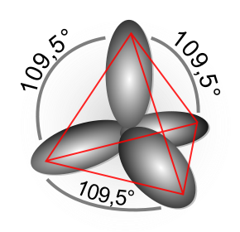
If we wanted to create four orbitals like this one by reshaping the s and p orbitals of an atom’s valent shell, we would need to start with one s and three p orbitals. We therefore call this bonding orbital an sp ³ hybrid orbital, because it looks like a hybrid between the one s and three p orbitals.
Similarly, molecules with three electron clouds are based on the trigonal planar VSEPR shape:
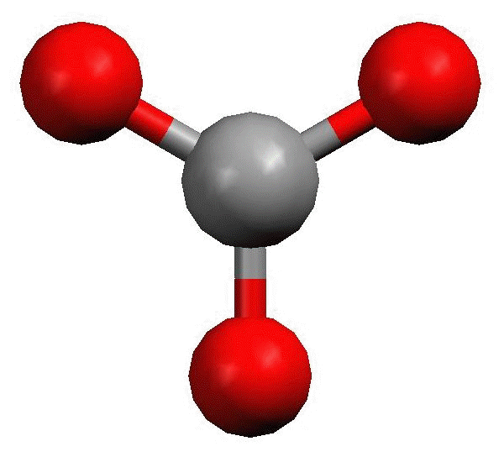
This hybrid orbital would come from one s and two p orbitals, and would be called an sp ² hybrid orbital:
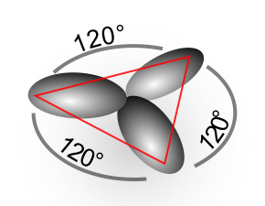
Finally, the hybrid orbital from one s and one p orbital is indeed called an sp hybrid orbital.
VSEPR Shapes for Hybrid Orbitals
Hybridization | VSEPR Shape(s)
sp³ | tetrahedral,  trigonal pyramidal,  bent (104.5°)
sp² | trigonal planar,  bent (118°)
sp | linear

